c
Yousra Mohamed Mahmoud Hamdy Ghzally

Address : House No. 1, street No.9, Takseem El Hokokeen on El Weledya, Assiut, Egypt. 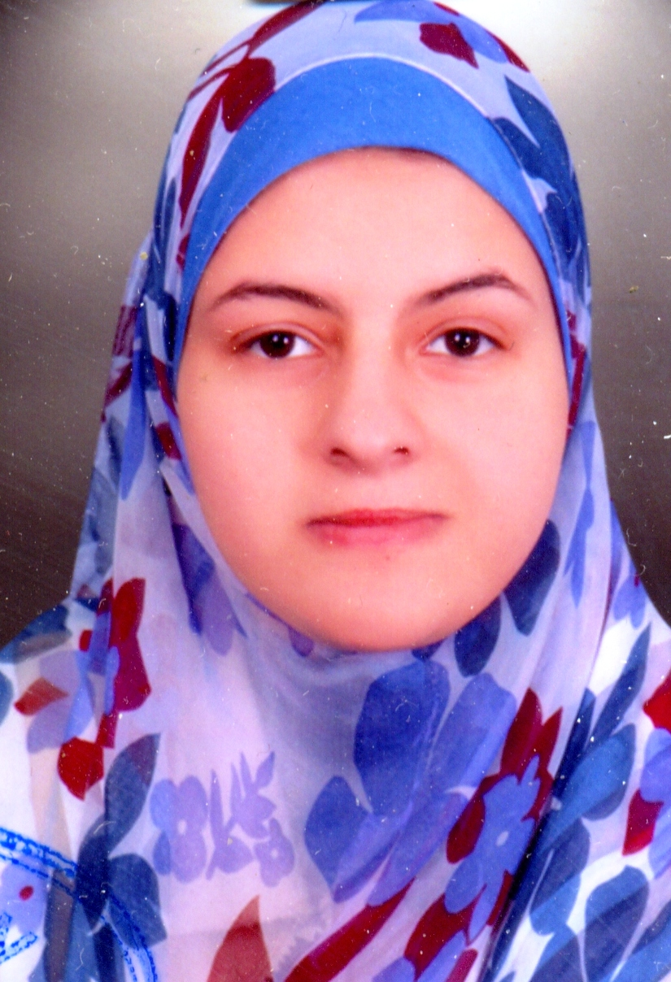p;
Telephone: (+2)0882328041/ 01003314748
E-mail : yousraghzally@yahoo.com.
Objective

To be an experienced doctor, with a wide range of experience in cardiology field, with high professional certifications and to transmit this experience to new generations later.
Employment history and experience

- Current occupation:
- Assistant Lecturer in the cardiology Department, Faculty of medicine, Assiut University, Egypt, from July 2012 up till now.
This department represents the largest and most important cardiology department in Upper Egypt and it belongs to one of the most famous and oldest universities in Egypt (Assiut University), our patients come from all other cities in Upper Egypt, we serve.
I have assisted in 150 cases of diagnostic coronary angiography, and 100 cases of percutaneous coronary intervention 20 cases of PTMC.
I have done 150 cases of diagnostic coronary angiography through femoral approach.
Assissted in 20 cases of DDD pacemaker and 30 cases of VVI pacemaker.

- Demonstrator of cardiovascular medicine from 1/3/2012 till 31/7/2012.
- Registrar of cardiology and internal medicine from 1/3/2009 up to 1/3/2012.
- Intern at Assiut University hospitals for 1 year from 1/3/2008 to 28/2/2009.
Education/ Certificates

- M.B., B. Ch. Faculty of medicine, Assiut University. (excellent with honor) Sept. 2007.
- Degree of M. Sc. : In cardiovascular and internal medicine(very good), faculty of medicine, Assiut university, April 20011
The title of the thesis: Assessing of cardiac dyssynchrony using 2D speckle tracking echocardiography in cardio myopathic patients.
- Two month training in the echocardiography lab, at Bad kronzingen heart center, Freiburg, Germany.

Computer skills

- International Computer Driving License (ICDL).
Language skills

- Arabic: native English: fluent
- German: good French: good

- TOEFL IBT total score 92.

- Local TOEFL institution test score record by total score: 590.
Personal data

- Date of Birth | : | 25/5/1984
- Gender | : | Female.
- Nationality | : | Egyptian.
- Marital Status | : | Married

- Have strong personal & Communication skills.

